**PROGRAM 1:** Write a Python Program which accepts the user’s first and last name print them in reverse order with a space between them.

**OUTPUT:**

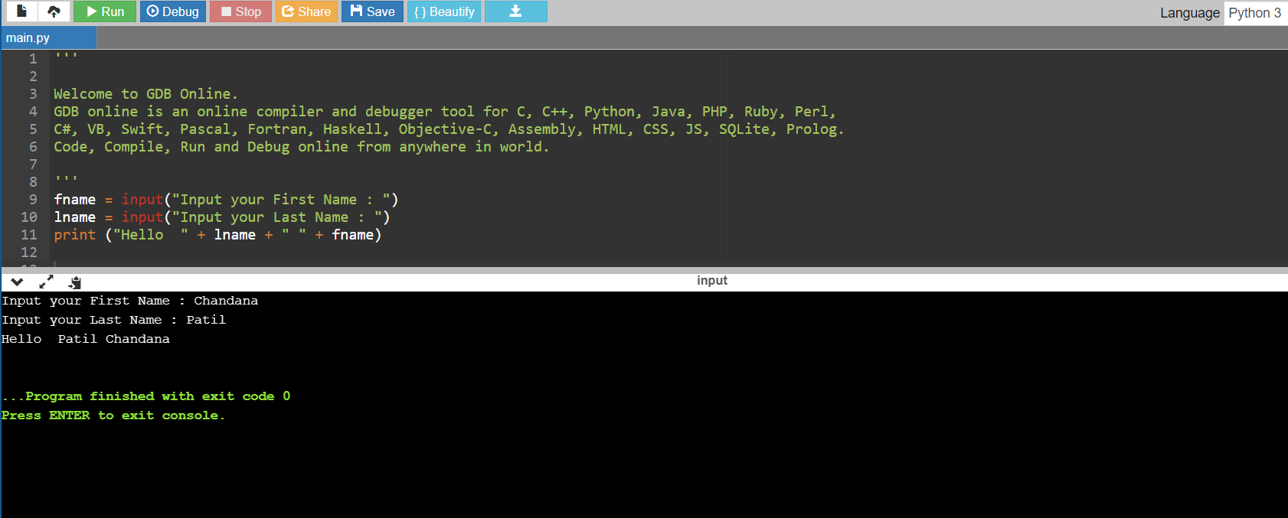

**PROGRAM 2:** Write a Python Program to calculate numbers of days between two dates.

**OUTPUT:**

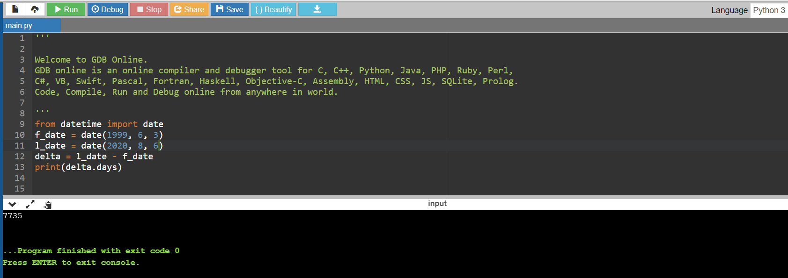

**PROGRAM 3:** Write a python program to test whether a passed letter is a vowel or not.

**OUTPUT:**

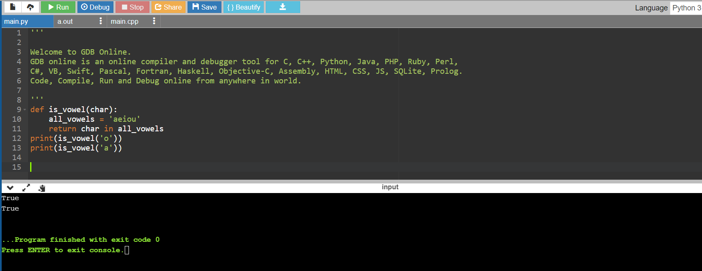

**PROGRAM 4:** Write a python program to sum of three given integers. however, if two values are equal sum will be zero.

**OUTPUT:**

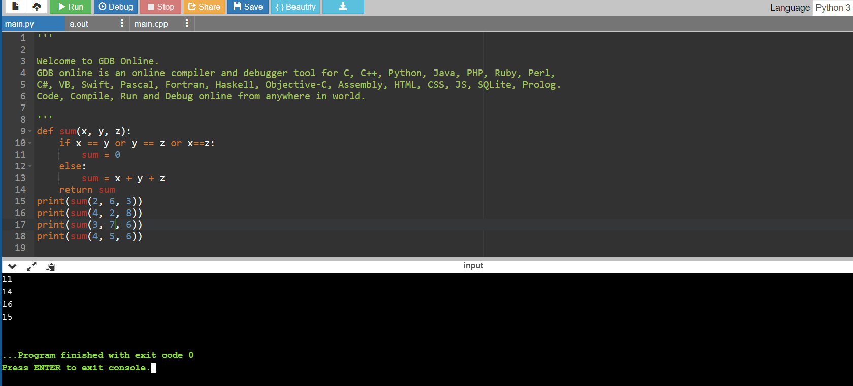

**PROGRAM 5:** Write a Python program to count the number of characters (character frequency) in a string.

**OUTPUT:**

